Centro Nazionale HPC, Big Data e Quantum Computing
Missione 4, Componente 2, Investimento 1.4
Codice progetto MUR: CN_00000013 - CUP: E63C22000980007

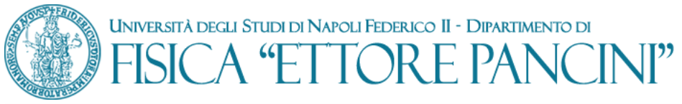

Model D
Replacement declaration for cohabiting family members

Substitute declaration of certification
(Presidential Decree n. 445 of 12.28.2000)

Negotiated procedure for the purchase of "Cryogenic system for Q-Bit cooling" for the needs of the National HPC Center, Big Data and Quantum Computing, Mission 4, Component 2, Investment 1.4, MUR project code: CN_00000013 - CUP: E63C22000980007

The undersigned (name and surname) _______________________________________________
born in__________________________ Province ________ on ________________; FISCAL CODE ________________________________resident in_____________________ street _____________________________________number____________
as________________________________________________________________________
of the society______________________________________________________________

aware of the penal sanctions in the event of false declarations and the consequent forfeiture of any benefits obtained (pursuant to articles 75 and 76 of Presidential Decree 445/2000) under one's own responsibility
DECLARE

- pursuant to art. 85, paragraph 3 of Legislative Decree 159/2011:

- that I currently have the following adult family members living together:

(NAME – SURNAME- DATE AND PLACE OF BORN – FISCAL CODE)____________

___________________________________________________________________

___________________________________________________________________

___________________________________________________________________

___________________________________________________________________

- and that, with reference to the last three years (tick the option corresponding to your condition):
  - the family situation referred to in point 1) has not changed

  - the adult family members living together were the following:

_(NAME – SURNAME- DATE AND PLACE OF BORN – FISCAL CODE)

______________________________________________________________

_______________________________________________________________

_______________________________________________________________

______________________________________________________________

______________________ ______________________________________________
date
signature of the declarant ()

      - Disclosure pursuant to article 13 of Regulation (EU) 679/2016 laying down rules on the processing of personal data.
The data collected with this form are processed for the purposes of the procedure for which they are issued and will be used exclusively for this purpose and, in any case, within the institutional activities of the University of Naples Federico II. The interested party has the rights referred to in articles 15-22 of the EU Regulation.
The data controller is the University, in the persons of the Rector and the Director General, in relation to the specific skills. To contact the owner, you can send an email to the following address: ateneo@pec.unina.it; or to the Data Protection Officer: rdp@unina.it; PEC rdp@pec.unina.it
Complete information relating to the processing of personal data collected is given on the University website:
http://www.unina.it/ateneo/statuto-e-normativa/privacy.

"family members living together" means "anyone who lives" with the subjects referred to in art. 85 of Legislative Decree 159/2011.
The self-declaration must be drawn up by all the subjects referred to in art. 85 of Legislative Decree 159/2011.

