CALL FOR APPLICATIONS - ERASMUS+ SCHOLARSHIPS mobility for studies
A.Y. 2022/2023 – DR 883 ON 8th march 2022
APPLICATION FORM
Students enrolled in PhD and Specialization Schools

This form , together with a copy od ID or passport, must be uploaded as a single pdf file (named with: REGISTRATION NUMBER, SURNAME, NAME) on the following page: https://forms.office.com/Pages/ResponsePage.aspx?id=auLPL2K7sEax4yj52gxF_ZLgAxRI7pFCtfDZGgbmMXJUM1pGWEdPV0VZS1hIQTlCMjNKRkxaMDNKWC4u
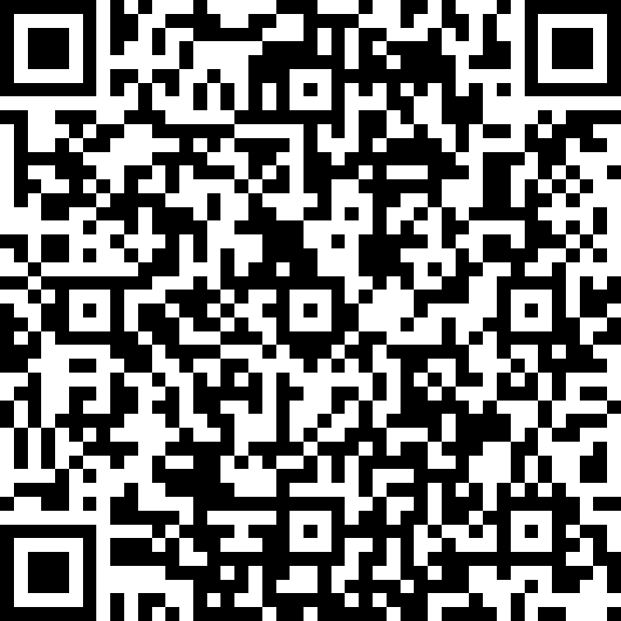 | To the rector  c/o Department of :  ___________________________

The undersigned____________________________________________________________________

Born in ______________________________ on _____________________________________________
Citizenship________________________________Fiscal Code _________________________________
Resident in ___________________________________________________(State________________)
Address __________________________________________________n. _______ postal code_________
Tel. ___/_______________; Cell._____________________ e-mail _____________________________
Emergency contact:____________________________
Enrolled in (PhD or Specialization Schools): ___________________________________________________________________________________
- Degree in (Bachelor degree)_________________________________________________ to the University of ______________________________________score ___________/_________
- Degree in (Master degree)________________________________________________ to the University of ______________________________________score ___________/_________
- Degree in (Master degree single cycle)_______________________________________to the University of ______________________________________score ___________/_________

CANDIDATES
To take part in the ERASMUS+ call for applications to the countries and universities listed hereafter:

N | COUNTRY | UNIVERSITY | PROMOTORE/PROFESSOR
1
2
3
(The applicant can list three possible destinations in order of preference for wich the 3rd level mobilities are clearly indicated)
AWARE OF SANCTIONS FOR FALSE DECLARATIONS, AS TO DEL D.P.R. N. 445/2000 SS.MM.
DECLARES
- To have benefited from other Erasmus scholarships during the running course of study for n. ______ months during the A.Y.______________ _________________________________________
- That duting the period of stay abroad wil not benefit form other European scholarships;
- To be aware that tha scholarships award is conditioned to the confirmation of the Bilateral agreements with the partner universities involved.

Napoli, ________________________ Signature _________________________________

Informativa ai sensi dell'art. 13 del Regolamento (UE) 679/2016 recante norme sul trattamento dei dati personali
I dati raccolti con il presente modulo sono trattati ai fini del procedimento per il quale vengono rilasciati e verranno utilizzati esclusivamente per tale scopo e comunque,nell'ambito delle attività istituzionali dell'Università degli Studi di Napoli Federico II.
All'interessato competono i diritti di cui agli artt. 15-22 del Regolamento UE.Titolare del trattamento è l'Università, nelle persone del Rettore e del Direttore Generale, in relazione alle specifiche competenze.
Per contattare il Titolare potrà inviarsi una email al seguente indirizzo: ateneo@pec.unina.it; oppure al Responsabile della Protezione dei Dati: rpd@unina.it; PEC: rpd@pec.unina.it.
Le informazioni complete relative al trattamento dei dati personali raccolti, sono riportate sul sito dell'Ateneo: http://www.unina.it/ateneo/statuto-e-normativa/privacy

