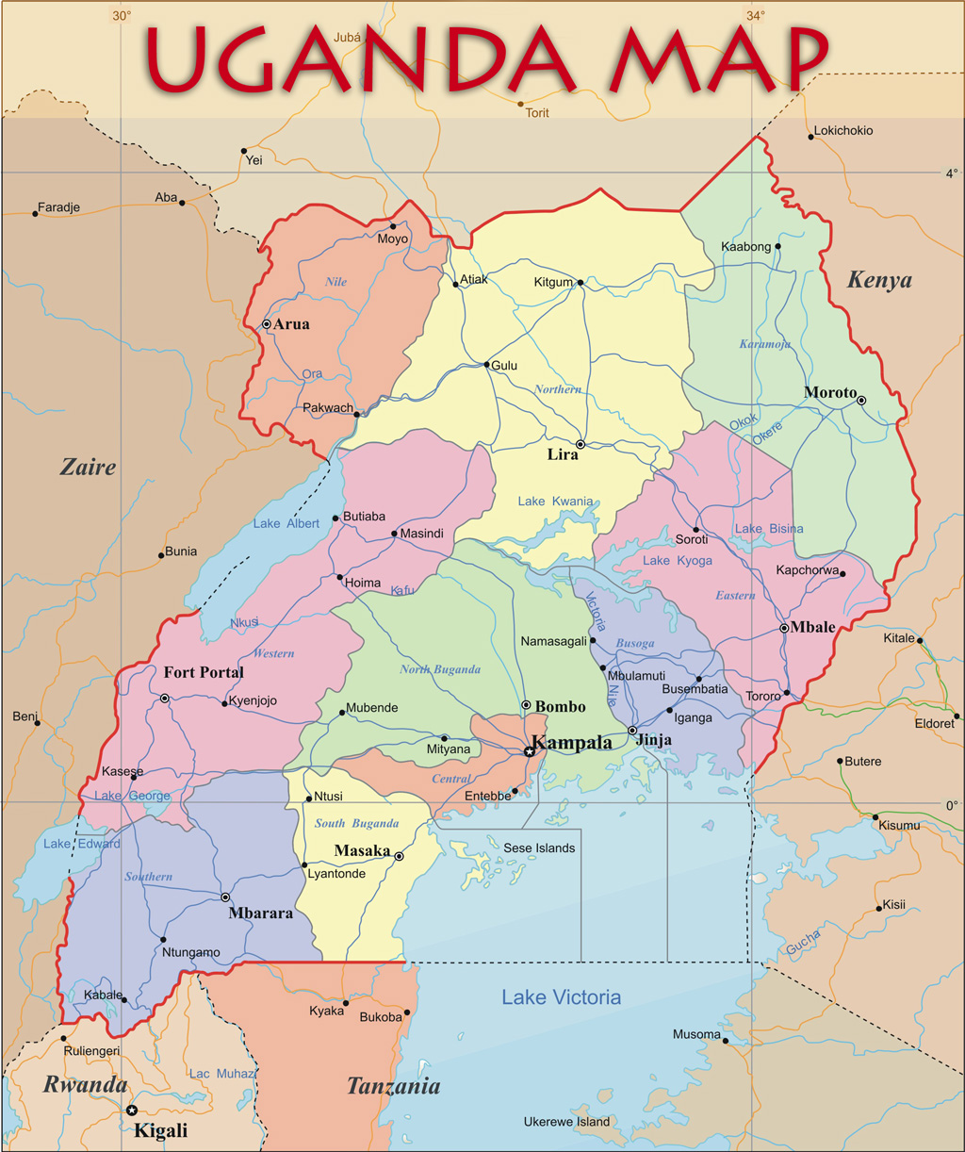

Thank you for your selfless initiative and passionate contributions towards the establishment and running of the Faculty of Medicine at Gulu University, Uganda. Your personal dreams and mobilisation of thoughtful partners pulled together resources / investments that tremendously provided opportunities for medical education and training in Uganda, and particularly to the most vulnerable and disadvantaged population of northern Uganda over the years.
Felix Kaducu, Preside della Facoltà di Medicina di Gulu in Uganda

